|  |
| --- |
| **Author Contact details**  **Author: Mohit Goel, Laxmi Ghate**  **e-mail:** [Mohit.Goel@bt.com](mailto:Mohit.Goel@bt.com), [Laxmi.Ghate@bt.com](mailto:Laxmi.Ghate@bt.com) |

BT Global Services – Inbound Contact Global

Self-service

Solution Design HLD

|  |  |
| --- | --- |
| Programme / Project Name: | BT Contact |
| Programme / Project No.: |  |
| Version Number: | 2.1 |
| Version Date: | 18-APR-2017 |

|  |  |
| --- | --- |
| Demand Story Reference: |  |
| CE Story Reference(s): |  |
| ACF Tag(s): | ACT45662 , ACT47403 ( ESB Changes) |
| LOB: | BT Global Services |
| Solution Status: |  |
| SACS | BEX-110 |
| Target Release: |  |
| Lead CE Designer: | Marie Greenidge |
| Lead Solution Architect /  E2E Designer: | David Millest |
| Design Assurance Link (JIRA) |  |

|  |  |
| --- | --- |
| Evolving Version No:: | Programme / Project State @ Version |
| 1 |  |
|  |  |

Contents

1 Executive Summary 5

2 Business Problem / Context 5

3 E2E IT Solution Design 6

As is and Proposed Solution 6

3.1 Proposed Solution 8

3.2 Summary of High Level OSS requirements 9

For Internal Customers - 10

3.3 STORM Story Overview & References: 10

3.5 Impacted Customer Experiences 11

3.6 Static Architecture 12

3.7 Service Flow Diagram for External Customer 13

3.8 Service Flow Dia for Internal Customer 14

3.9 System Impacts 15

3.10 MNUM: Number Management System 15

3.11 VLP-IC 21

3.12 VLP – BFG Interface Impacts 27

3.13 ESB – Enterprise Service BUS 28

3.14 Billing and Mediation 29

3.15 BFG 29

3.16 Provide Order Business Scenarios: 30

4 Risks 38

5 Assumptions 38

6 Issues 39

7 Design Decisions 39

8 Process/Configuration/Data Load on MNUM & VLP 41

8.1 MNUM 41

8.2 VLP 42

9 E2E/CIT Test Scenarios 42

10 Non-Functional Considerations 42

11 Future Enhancements – 43

12 Requirement Conformance 43

13 VLP MNUM – Phased Delivery and Provide Scenarios Mapping 43

Glossary 43

References 44

**Approvers, Reviewers & Change Log**

|  |  |  |
| --- | --- | --- |
| Approver Name | Role | Date Approved |
| Julian Foxhall | Voice Portfolio Architect |  |
| Shaun Brame | POD Architect |  |
| David Millest | SSD |  |
| Kathleen Lyons | Product Line |  |
| Ambika Rana (Service Design) | SDA |  |
|  |  |  |

|  |  |  |  |
| --- | --- | --- | --- |
| Reviewer Name | Role | Date Reviewed | Review Comments |
| Shaun Brame | POD Lead | 4-Aug-2017 | Changes in Context and flows, Executive summary |
| David Millest | E2E Designer | 4-Aug-2017 | Changes in Diagrams |
| Julian Foxhall | POD Architect | 4-Aug-2017 | Suggested changes in , Executive summary |
|  |  |  |  |

|  |  |  |  |
| --- | --- | --- | --- |
| Version | Date | Changed By | Reason |
| 1 to 1.5 | 31-Jul-2017 | Laxmi, Mohit | Rounds of review and accommodating the review comments |
| 1.6 | 18-Sep-2017 | Laxmi Ghate | * Included Report Changes for MNUM section Reports on MNUM * VLP IC Impact for Ceased data Display section 8 * Added World Zone VLP-IC Section * ReservedForDDI to Premapped DDI * App ID Re-use * Corrected the AccessTypes as per MNUM WSDL |
| 1.7 | 21-Sep | Laxmi/Mohit | Updated Billing and Mediation section |
| 1.8 | 26-Oct | Mohit Goel | Added VLP enhancement requirement design as well |
| 1.9 | 16-Nov | Mohit Goel | MNUM permanent deletion of access number for a cease request |
| 2.0 | 14-Dec | Laxm & Mohit | Additional MNUM Requirement for release BK |
| 2.1 | 18-Apr-2018 | Laxmi & Mohit | VLP Bulk upload requirement, MNUM Enhancement |

# Executive Summary

Today, suitably trained “Emerald” level customers, can be authorised through the GS Portal and connect to Call Traffic Controller (known internally as VLP-IC) in order to make changes to their routing plans. This is seen as a key differentiator between BT’s Inbound routing product and that of our competitors.

This project is to extend this self-service capability further by allowing the customers to select new Access Numbers and add those to their service. In order to enable this functionality the management of the Dialled Access Number inventory is required to be moved from IPMS and spreadsheets, into VLP-IC and MNUM, such that this can achieved in real time in a fully automated way.

Further analysis indicated that a separate provisioning process for Customer and BT Operations was not acceptable. Also not acceptable was for Operations to use the VLP/MNUM solution for the subset of countries that would be enabled for Self-service, but their existing VLP/IPMS/Spreadsheet process for all other countries. This meant that, although not explicitly stated in the SoR, the management of both Dialled Access numbers and Network delivery numbers, including number types that will never be available to customer self-service, all needed to move to the VLP/MNUM management. The provisioning processes for Operations, both in the management of the number pool, and service provisioning have all needed to be changed to utilise the new systems. This has made it a much larger and more complex project than perceived from the SoR.

# Business Problem / Context

Allowing customers to select and provision new access numbers keeps BT competitive. BT has competitor like Orange and AT&T Domestic, which provide this functionality to customers.

Meets customer demand and moved basic functionality from the BT provisioning team to external customers. This should also result in quicker turn up of numbers and therefore ability to bring in revenue sooner.

Inbound Contact global has an objective to double the percentage of customer self-service orders. To reach this goal, customers need more control over their Inbound service. The additional customer control will include the ability to reserve and Provision new access numbers.

This project is split in two-three release, below are the storm stories created on STORM to cover the functionality to be delivered

**GSCE-181825 (R47)**

**GSCE-196074 (R51 / Release BH)  
GSCE-199780 (R52 / Release BI)  
GSCE-199242 (R53 / Release BJ)**

# E2E IT Solution Design

### As is and Proposed Solution

Currently IPMS and spreadsheets are being used for the number management of ICg, as part of this story the number management will be moved on BT’s strategic number management System – MNUM (also known as LiANS.). This is being done for the following reasons:

1. IPMS is a legacy system and no new developments are permitted.
2. The existing interaction with IPMS is manual and cases of double allocation due to inaccurate records do occur.
3. MNUM is BT’s strategic number management system and already has a defined interface with VLP.
4. MNUM provides the suitable reports that BT has to provide to the various Telephony Regulators in countries where it takes numbers directly from the regulator.

VLP-IC is used today by BT Service Delivery teams to build Customer Services. The Access Numbers, and their respective mapped DDI numbers where applicable, are manually entered into VLP-IC. The proposal is for VLP-IC to interact directly with MNUM and display the list of available numbers of the relevant type in the chosen country and hence to allow the Service Delivery teams to select from the list. There will be instances where BT has to request a local operator to provide suitable numbers on request, and VLP-IC will allow these numbers to be entered directly and it will create the relevant records in MNUM.

In a subset of countries where BT holds Access Numbers in supply and has these pre-mapped to their equivalent network delivery number (DDI), then we will allow Customers to select from these Access Numbers as a self-service option. It is expected that this is around 25 countries of the 160+ that ICg is available in.

There are several types of Access Number and also methods of their delivery to the edge of the BT Network, which leads to several different provisioning scenarios. An overview of the different number types is given below:

|  |  |
| --- | --- |
| **Access Number Type** | **Description** |
| Domestic Toll Free (DTF) | A free to call phone number that is only diallable from within that country. |
| Direct Toll Free (2 stage dialling) | Some countries do not offer direct dial free phone, instead they have a 2 stage dialling equivalent. |
| International Toll Free (ITF) | A free to call phone number that is internationally diallable, i.e. may be called from another country. |
| National Rate | A non-geographic number that costs the caller the standard national rate, e.g. the 0870 range in the UK. |
| Shared Cost | A number which is cheaper than national rate for the caller, often costing the same as a domestic local PSTN call. The called company also pays a cost for calls to this number. E.g. the 0845 range in the UK. |
| PSTN | A standard caller-pays number. In some countries these numbers are tied to a specific geographic area. |
| Universal International Freephone Number (UIFN) | A special range of free phone number where the same number is available to be called from many countries. These have the country code of +800. These are expensive for the called party and not heavily used. |

Depending on the Country and BT’s partner operator in that country there are different ways a call can be delivered to BT. The Network delivery number is often called the DDI:

|  |  |
| --- | --- |
| **Network Delivery Type** | **Description** |
| As dialled | Here the number is delivered to BT exactly as it was dialled, there is no need for a mapped DDI number. This applies to all PSTN numbers, and also some DTF numbers in some countries. |
| Mapped PSTN DDI | The dialled number is mapped by the partner operator to a PSTN number which is delivered to BT. This means that BT has to purchase 2 numbers from the operator, the PSTN number and the DTF/ITF/Nat/Shared Cost/etc. |
| Mapped Network Code | Some operators such as Verizon and AT&T have allocated BT some 10k ranges of 7-digit network codes. These codes are used instead of a separate PSTN number. On the front of these network codes are 2 hexadecimal digits [A-F], these are allocated during the network build and these hex details are not required during the VLP-IC provisioning. |

Currently the number management is done semi-automated way, Numbers are loaded on IPMS, and From IPMS numbers are manually chosen and updated on VLP. The status of the numbers is updated manually on IPMS. There isn’t any integration between IPMS and VLP, hence the number updates/Status Changes /Deletion of the numbers are all handled separately.

The proposed solution is discussed in section below.

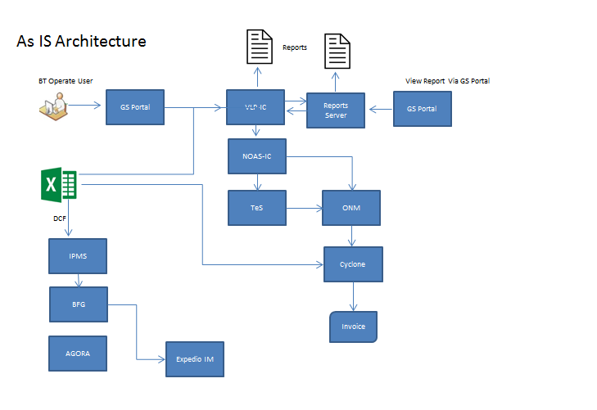

## Proposed Solution

* As part this story we are giving provision to external customer to do self-service – i.e. select the Access Number and provision the service. Currently only BT Operate (internal) users can do this on VLP
* Use of BT’s Strategic number management System MNUM to manage the number life cycle
* The proposed solution uses MNUM to store the All numbers ( Dialled Access Number, DDI, Network Code-Psedo DDI)
* Interface between MNUM and VLP to handle the number management cycle, VLP being at the front and MNUM at the back –handling the numbers and their statuses.
* On VLP the Internal/External customers can choose the access number of their choice and continue provisioning( Configure Routing Plan)
* There are various scenarios for which Internal customers can do the self-service which are discussed in detail in below sections.
* BFG ID is made mandatory to be provided on VLP corresponding to each Corp ID
* Customer ID will be always be validated against BFG and then customer
* Customer contract, Site creation from VLP on BFG.
* Various Reports on MNUM for understanding the number utilization, available number pool, Country wise numbers etc.
* Performance reports on VLP

.

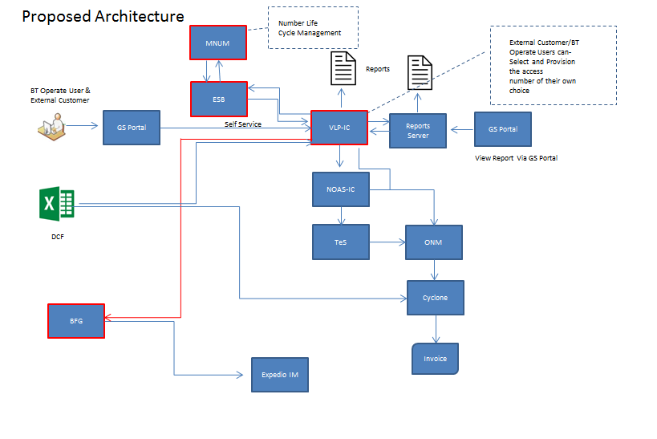

## Summary of High Level OSS requirements

For External Customers –

* The customer should be able to login to GS Portal, customer should be able to self-service – (place the order for the Dialled Access Number based on the country) (the access number and for a given country and number type), VLP queries the next available number in MNUM on the basis of search criteria provided by user. 3 numbers which are matching the criteria are to be shown from the spare pool. (The Number status maintained at MNUM are provided in below sections of this document)
* The numbers to be mastered in MNUM (Move all the existing numbers from IPMS and spared sheet which is manually maintained at the moment by Ops (Toni ) to MNUM).
* User to provide the initial 3 to 5 digit/or entire number without any special characters for search the number.
* After selecting the number(s) that they wish to use, they continue to specify the features that they want and then provision the access numbers, dial plan, B Number/Network Address realization for a dialled number will be automatic on VLP
* This order provisioning will be near to real time in the countries where BT owns the Switch, in other cases provisioning process may take time.
* Capacity Check to be performed for the number of minutes - An email notification would be sent to the Network Ops team (Ian Fothergill’ s Team) in case the threshold limit is breached.( > 50,000 minutes per month). Process to outline the detailed steps
* For a dialled number there will have to be a Geographic number/Network Number (Pseudo Number) to be associated with. There are various scenarios for this mapping; these are discussed in detail in below sections. Only few types for scenarios will be available for an external customer to self-service. Process to outline the detailed scenarios.
* Billing - Cyclone Ops team to download the Dial plan report from VLP to understand the newly added Dialled Access Numbers (VLP to add additional column in this report to include the number creation date) and configure the billing for the newly added Dialled Access Numbers.
* In case of External customer – the first order for ICg ( On Boarding of a new ICg Customer ) will always be via BT operate users, Further changes /Acquiring new Number/Deleting the number etc. can be self-serviced by the customer .

### For Internal Customers -

* BT operates (Order management) Team to place the order for dialled access number on the basis of DCF.
* User to select the country, access type and quantity.
* User to provide the initial **3 to 5 digit/or entire number** without any special characters for search the number.
* VLP queries the next available number in MNUM on the basis of search criteria provided by user. There is no restriction of displaying 3 numbers in case of internal customers; the count is configurable at VLP end.
* MNUM to return the number to VLP on the basis of search criteria.
* User to select numbers out of the available numbers and proceed with the provisioning process.
* ~~Capacity Check: An email notification would be sent to the Network Ops team (Ian Fothergill Team) in case the threshold limit is breached. ( > 50,000 minutes per month).~~ – For Internal customers no capacity check need to be done, This step to be bypassed for internal customers.
* B Number/Network Address (Pseudo number) to be built in VLP. This
* There are two types of B Number realizations – 1> Automated 2> Manual. B number realization scenarios for both Automated and Manual are discussed in detail in the below sections.
* Billing - BAU – as for internal customer the provisioning is based on the DCF. The existing process to be followed

## STORM Story Overview & References:

[GSCE-199242](https://collaborate.bt.com/storm/browse/GSCE-199242)

|  |  |  |
| --- | --- | --- |
| **Description** | | |
| As a customer | I want to consume (receive quote, place order, take delivery, receive a bill, make a payment and have assured) BT's New Inbound Contact Global Self-Service capability | So that I can use the service offered by BT within my business |
|  | | |

The CE story has all generic Acceptance criterions.

## 

## Impacted Customer Experiences

Yes. All the customer journeys are impacted.

|  |  |  |  |  |  |  |
| --- | --- | --- | --- | --- | --- | --- |
| **#** | **E2E Journey** | **Impact** | | | **Business Process Block** | **Comment** |
| CT | RFT | PI |
| 1 | C2M | NA | NA | NA |  |  |
| 1.1 | Product Model Data build & distribution | N |
| 1.2 | Infrastructure Plan & Build | Y(Number related data from IPMS needs to be migrated to MNUM-LiANS) |
| 2 | L2C | NA | Y | NA |  |  |
| 2.1 | Manage Customer Contact | Customer User Guides need to be updated for self service |
| 2.2 | Sell Service aka Q2O | N |
| 2.3 | Fulfil Service aka Service Delivery | Y(Self-service will add extra triggers for Capacity Management and Billing) and updated L2C Workflow |
| 2.4 | Manage Contract | N |
| 2.5 | Obtain Payment aka Bill & invoice | In case of External Customer – Cyclone team to refer to the Report on VLP – Process change |
| 3 | T2R | NA | Y | NA |  |  |
| 3.1 | Manage Customer Contact | Updated Structured questions |
| 3.2 | Manage Event | N |
| 3.3 | Manage Incident | Y(New potential issues around customer access to VLP-IC and self-provisioning) |
| 3.4 | Manage Problem | N |
| 3.5 | Obtain Payment | N |
| 3.6 | Manage Performance | N |
| 4 | In-life | NA | NA | NA |  |  |
| 4.1 | Reporting | N |
| 4.2 | Business Continuity Mgmt | N |
| 4.3 | Capacity Mgmt | N |

# 

## Static Architecture

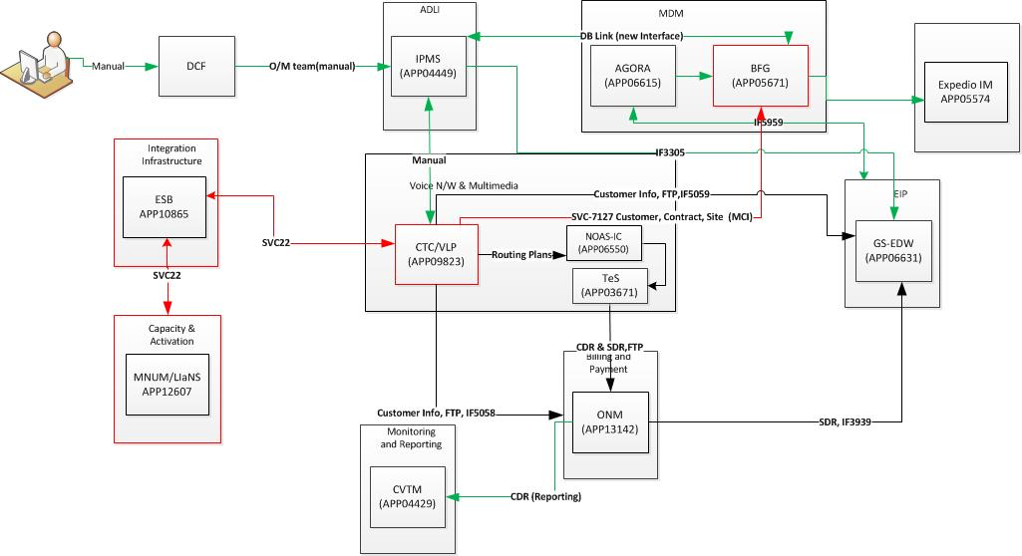

Impacted Components shown in Red.

**Figure 1 Static Diagram for Inbound Contact Global**

## Service Flow Diagram for External Customer

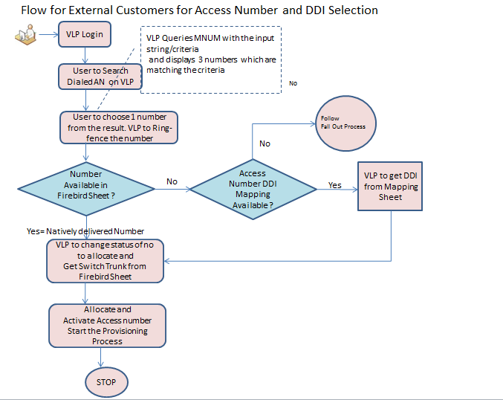

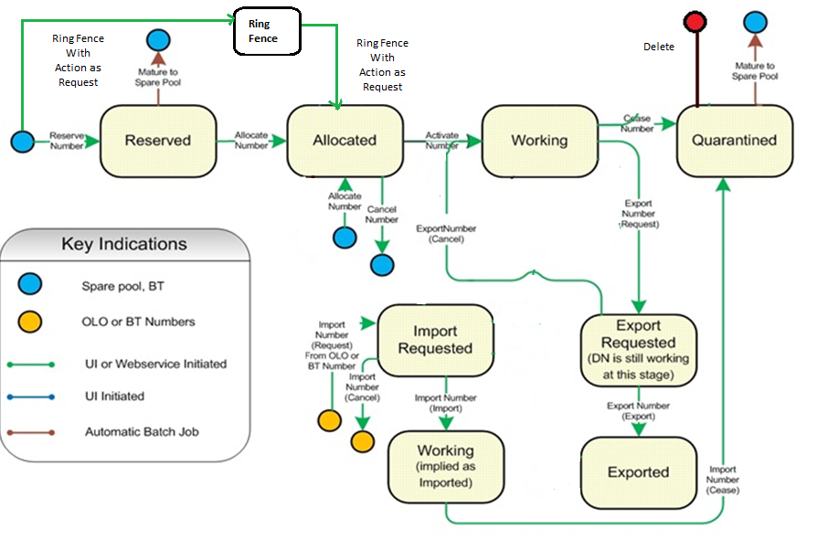

## Service Flow Dia for Internal Customer

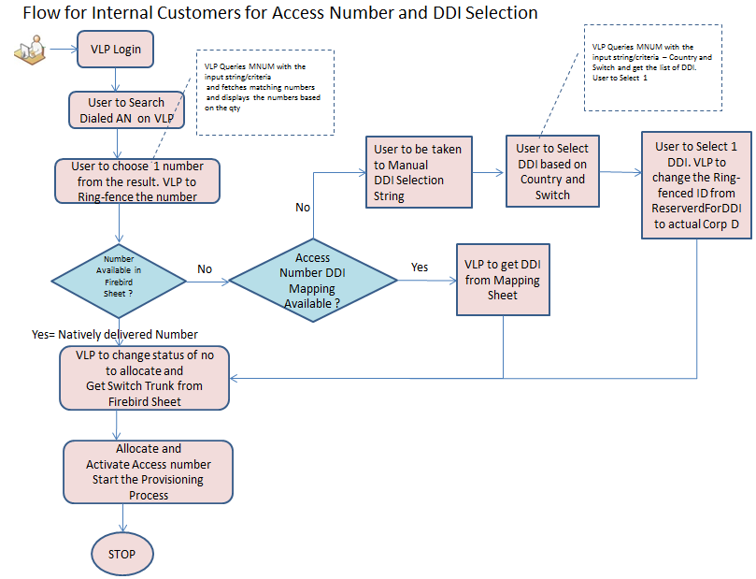

## System Impacts

|  |  |  |  |  |  |  |
| --- | --- | --- | --- | --- | --- | --- |
| **#** | **System/Interfaces** | **Impact**  (H / M / L / None) | **Change** | | | |
| **Data Build** | **Configuration** | **Coding** | **Process** |
| 1 | VLP | H | 🗶 | 🗶 | ✓ | 🗶 |
| 2 | MNUM | H | 🗶 | 🗶 | ✓ | 🗶 |
| 3 | ESB | L | 🗶 | 🗶 | ✓ | 🗶 |
| 4 | BFG | M | 🗶 | 🗶 | ✓ | 🗶 |
| 5 | Cyclone | L | 🗶 | 🗶 | 🗶 | ✓ |
| 6 | ONM | Test Only | 🗶 | 🗶 | 🗶 | 🗶 |
| 7 | IPMS | Data Uplift | ✓ | 🗶 | 🗶 | 🗶 |

## MNUM: Number Management System

* MNUM to create placeholder for all Dialled Access Numbers and Geographic numbers of Inbound Contact Global for all countries. A generic solution for Inbound Contact Global is to be delivered.
* ICG is to be created a dummy country in MNUM Division1 as MNUM have different logic for different country.
* All 160+ countries are to be loaded as Division2 in MNUM.
* All Switch ID –~~Name~~ ~~-Trunk~~ information is to be loaded in Division3 in MNUM. **( ID and Name values for DIv 3 will be Switch ID )**

Following Divisions will be created on MNUM

|  |  |  |
| --- | --- | --- |
| Div1 ( Root product Name)  Country | Div2  Region | Div 3  **Switch** |
| **ICg**  **Div ID – 300** | **Country Name**  **Div Code – Country Code**  **Div Name – Country Name**  **ISO Code – Short Code for Country Name** | **Div Code – Switch ID**  **Div Name –Switch Name** |
| In Div 2 – Additional column for ISO Code (Short Code ) for country will be maintained to solve the issue of Countries having same Code e.g USA and Canada both have code as 1. Hence Additionally USA and CAN will also be stored in div 2 | | |

* All Dialled access number and Geographic numbers are to be loaded in least division in MNUM which is Division3.
* All the suppliers to be set as default supplier so that number can be created against suppliers those in MNUM. ( TD – Provide supplier List)
* All the suppliers (third party) are to be made as default suppliers. (In ICg – there are many suppliers who can own the numbers)
* **MNUM to support the Access Number porting functionality which can be used in future release**
* Following are the number types created in MNUM

|  |  |  |  |  |
| --- | --- | --- | --- | --- |
| **Number Type** | **MNUM**  **Div 1 Value** | **MNUM**  **Div 2 Value** | **MNUM**  **Div 3 value** | **MNUM**  **Number Type** |
| Domestic Toll Free | ICG | *<Country Name>* | *<Country Name>* | DomesticTollFree |
| Direct Toll Free | ICG | *<Country Name>* | *<Country Name>* | DirectTollFree |
| International Toll Free | ICG | *<Country Name>* | *<Country Name>* | InternationalTollFree |
| National Rate | ICG | *<Country Name>* | <Country Name> | NationalRate |
| Shared Cost | ICG | *<Country Name>* | <Country Name> | SharedCost |
| PSTN Caller Pays | ICG | *<Country Name>* | *<Switch Name/ID>* | Geographic |
| Pseudo/network routing code | ICG | *<Country Name>* | *<Switch Name/ID>* | NWRC |
| UIFN | ICG | *“Global”* | *“Global”* | UIFN |

#### Access Number Search/Cancel/Delete

* MNUM to provide an API for the Number search from VLP.
  + **Following are the fields which will be selected on VLP.**
    - Search Type
    - Search Number ( Number String ) – ( The complete or Partial Number can be searched)
    - Product Code ( default value will be – INBOUND CONTACT GLOBAL)
    - Number Type
    - Div 2 - Country
    - Quantity ( Configurable for Internal Customers, Default to 3 for External Customers)
    - Division 3 ( Optional )
  + MNUM to search the Access Numbers based on the following parameters ( Country ISO Code and Number string is introduced in this search)

|  |  |
| --- | --- |
| **Search criteria** | **Attribute type** |
| Country Code | Mandatory |
| Country ISO Code | Mandatory |
| Number Type | Mandatory |
| Product code | Mandatory |
| Quantity (Only for BT operate User) | Mandatory |
| Number Lookup | Not Mandatory |
| Division3 | Not Mandatory/Optional |

* MNUM will support the number search based on just Div 2 value if Div 3 Value is not sent even if the div 3 value is populated in MNUM. ( in another words Div 3 be optional even if its defined in MNUM)  -  For the Vital functionality of Access Number DDI mapping of Self Service.
* Existing number search does not consider Country ISO Code ( To resolve the US, Canada Issue – Countries having same ISD code – the Number search is to be changed to include the ISO Code –short code )
* MNUM to provide the deletion of number permanently from MNUM database when the number cease request is sent – **This will consider Third Party owned /BT owned/ Customer Owned Numbers**
* Cancel number request is as BAU in MNUM (Numbers will be in spare pool after cancel number request is made). This cancellation – refers to cancellation of the ring-fenced number. There is a business requirement to move DDI to Geo numbers. Currently Geo numbers which are going to be used as DDI are ring-fenced. Cancel ring-fence is to bring back those numbers to be used as normal Geo number.

#### DDI Ring-fence/Cancel/Delete

* Ring-fence search operation at MNUM to be extended - new ring fence operation to be introduced for DDI/Network Code.
* This ring-fence number search from VLP should also be supported.
* This ring-fence number search operation is to find the DDI from MNUM database as per the Country, switch ID.
* Ring-fence Search operation have to be on the basis of different divisions and Number lookup string as well, details given below –
* MNUM to provide spare numbers in Ring-fenced state having the provided Ring-fence ID in the search parameter

|  |  |  |
| --- | --- | --- |
| **Search criteria** | **Attribute type** | **Value** |
| Ringfenced Order ID | Mandatory | “ReservedForDDI” in case of DDI/ Search else |
| Div 2 - Country- | Mandatory | Choice of Country |
| Number Type | Mandatory | Number Type |
| Number status | Mandatory | Ringfenced Number search |
| Product code | Mandatory | ICg |
| Number Lookup | Not Mandatory | Can be provided full number |
| Div 3 Switch (Div3 for MNUM) | Mandatory | Choice on the basis of selected country |

* Modify ring-fence operation to be supported from VLP to MNUM
  + This modify operation will replace the Ring Fence ID from “ReservedForDDI” to the Customer Corp ID
* MNUM will need the following operations to be called for Modify Ring Fence from VLP – ( exact texts of the operation name will be decided during Low level discussions)
  + **1>** MODIFY RING FENCE - ( this will split the Number ranges at MNUM end )
  + **2>** MODIFYCONFIRM RING FENCE. To be sent from VLP.
  + **MODIFY RING FENCE** operation will move the number out of the ring fence block/range, MNUM will need start number, end number ( it will be same in case of ICg – e.g. if the number in question is 1234, start number range and end number range values will be same)
  + **MODIFYCONFIRM RING FENCE**. New ring fence ID will be sent to MNUM in this call. ( “ReservedForDDI” to be changed with actual Customer Corp ID)
* Cancellation of individual/block range ring-fence operation to be implemented at MNUM end. Currently MNUM doesn’t support the individual number to be Un-Ring-fenced if numbers are ring-fenced for a block of numbers. (from MNUM GUI)
* MNUM to support permanent deletion of the numbers ( ceased numbers) – Hard Delete– ( exact texts of the operation name will be decided during Low level discussions) For this the number needs to be deleted from the RingFence table
  + MNUM to get two requests from VLP –
    - Cease Ring fence request
    - Cease Number Request

#### MNUM Number Types and short codes

* Following are the MNUM Number Types and the

|  |  |
| --- | --- |
| Number Type | Short Value |
| Geographic | G |
| DomesticTollFree | D |
| InternationalTollFree | I |
| DirectTollFree | R |
| UIFN | U |
| VOIP | V |
| SharedCost | S |
| Premium | P |
| NationalRate | C |
| NWRC | W |

#### Reports on MNUM

* MNUM to create reports apart from Generic reports. Reports on the basis of Different division number type and number status.
* Below are the filters criterions which you need to include for reports for ICg country.
  + Reports on the basis of different divisions and Number type. Column to be displayed as
    - 1. Div1
    - 2. Div2 (If selected)
    - 3. Div3 Name (If selected)
    - 4. Div3 ID (If selected)
    - 5. Access number
    - 6. Status of access number
    - 7. Number Type
    - 8. Operator
  + Ring-fenced number reports on the basis of different division. Column to be displayed as 1. Div1 2. Div2 (If selected) 3. Div3 Name (If selected) 4. Div3 ID (If selected) 5. Number 6. Status of number 7. Ringfence ID 8. Number Type



* Country is made mandatory to reduce the performance issue at MNUM end; User should be able to fetch report based on the supplier itself.
* Multiple selection for Switch IDs should be enabled…Switch ID-Name  should be displayed
* Multiple selection for Number Types should be enabled
* No Field is mandatory – however to run the report at least one selection should be made.
* Auto-completion of the values should be implemented for all the fields
* Ring Fence ID will be a Text box.

#### MNUM Generic/Adhoc/One-time Requests

* 2 new Number types to be created.  **1. NWRC 2. National.**
* MNUM to provide the one of script for reference data change in MNUM.
* Process to be defined for reference data change in MNUM.
* Network Code will be stored in MNUM as new access type called “NWRC”.
* **MNUM to support the BT Owned/Supplier Owned number creation on the fly from VLP. This particular scenario is for prebuilt numbers in the allocated state.**
* MNUM Country Number Plan Updates (e.g. Vietnam) – MNUM to support country plan changes
* Bulk Upload of the numbers from MNUM screen needs to be supported
* The ring fence is available for 3 months. If there is no order placed within 3 month the Numbers will be released and move to spare pool.
* For Trial launch MNUM to use dummy (Div 2) values in Div 3 for all the calls as the calls from VLP will get updated during full launch at VLP End.
* Bulk Upload of the numbers
* Support – Search, Ring-fence, Allocate, Activate, Cease etc
* Build Script for one time data load
* The numbers which are Ring – Fenced, this ring-fence is available for 3 months. If there is no order placed within 3 months, the Numbers will be released and move to spare pool.

#### UIFN (No extra Req, Instructions to be followed during data load)

* MNUM to define the dummy country as Global with country code as 999 in Div2.Same dummy details to be defined for Div3 as well under Div2.

#### MNUM Access

* Access to MNUM GUI is to be requested through order gateway portal. Network Operations team would be using it to upload/delete etc number ranges and view standard reports.
* MNUM will provide UIs that would be used by NM&P team for logging into MNUM, selecting the country and adding the number blocks for the country and respective Switch MNUM will support different access types under a country and will validate the added numbers against the same.
* MNUM will support various operations against number blocks (merge ranges, split ranges, etc.). It will also be able to generate various reports based on country requirement for NM&P team.
* Numbers to be loaded on MNUM via GUI could be owned by BT, Third Party, following dia displays the actions/sequence of the same

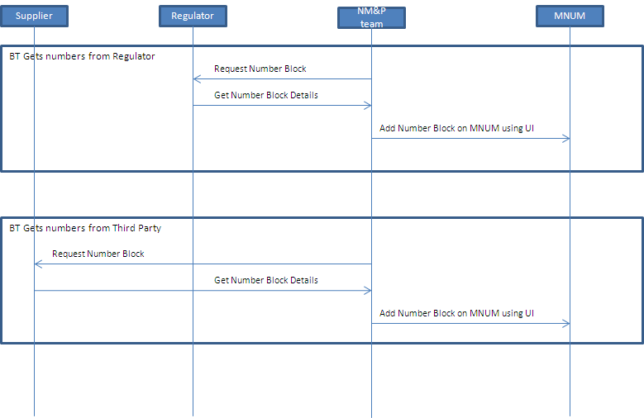

* Create number range page from MNUM. Going forward these screens will be used for creating number ranges for Inbound Contact Global.

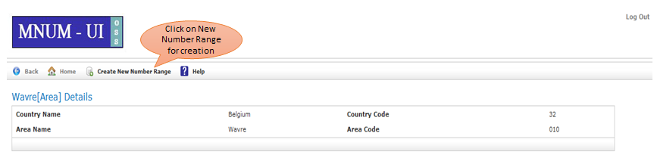

#### Number Life Cycle in MNUM

Dialled Numbers would follow sub allocated life cycle within MNUM, i.e. along with the ring fencing though. Broadly they can be classified into following three life cycles:

1. **BT New DN provide**
   1. Spare 🡪 Ring Fence 🡪 Allocate 🡪 Import/Export/Activate 🡪 Quarantine 🡪 Spare
   2. Spare 🡪 Allocate 🡪 Activate 🡪 Import/Export/Quarantine 🡪 Spare

*\* As per the latest design for Ring Fence in AO +, DNs can be un-ring fenced as any given point of time, this will result in DNs continuing in BAU lifecycle.*

#### MNUM new requirement as part of BK release:

1. Deletion of an access number permanently from MNUM database for a cease request. Currently numbers are being moved to quarantine state after getting cease request.

Number will stay in quarantine state for 1 year and then number will be available to allocate for any customer.

As per BT process numbers are being purchased from suppliers and once BT completes the use to those number, will be returned back to suppliers again.

MNUM to provide the functionality to delete the number permanently from MNUM for a cease request.

1. When adding supplier, don’t ask user to enter “Yes” for Default Rangeholder. Instead, just auto use the value “Yes". Hide from Screen and Yes option should be auto populated behind the scene.
2. Under "Range Holder" on "Create New Number Range", display Operator Name instead of Operator code.

Supplier code will not need restricted.At present MNUM is displaying the operator code in the Range holder drop down list in create number range screen.

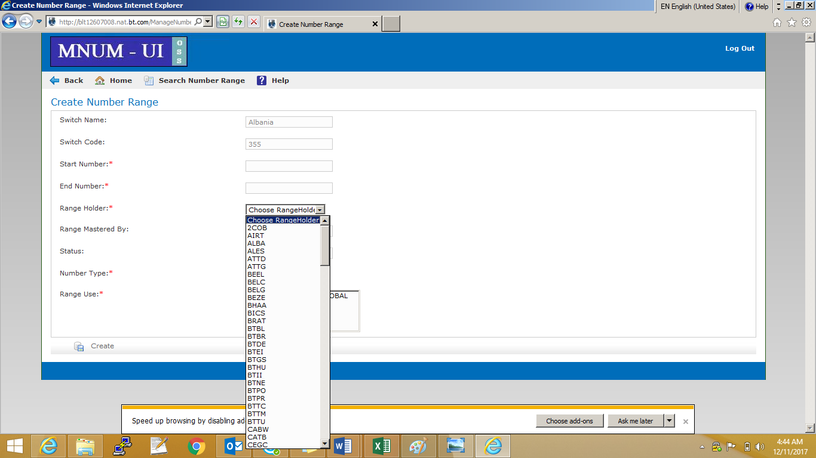

1. When creating new number range, auto open range instead of asking users to do it. Currently MNUM creates ranges in PLANNED status by default and user needs to manually open the range to start using the numbers in the range. Going forward MNUM needs to open
2. Create a pop up message for the user informing them that there are no records to output
3. MNUM to make Ringfence id as optional and to generate report across all the ring-fence id under a region when no Ring-fence id is been selected. If ring-fence id is been selected then MNUM to populate report based on that particular Ring-fence ID. Region would remain mandatory in Ring-fence based report.
4. Remove option to type and search for “Ringfence Order ID” and instead replace it with a drop down list or radial buttons which allow selecting either “ReservedForDDI” or “PremappedDDI”, to avoid any typing errors

If none of the value is been selected then MNUM has to generate across all the available ring-fence id under the chosen region.

1. Create a search facility to allow searching via either country code or country name - MNUM has to remove the case sensitivity while searching region name and sort the results found in the alphabetical order of region name
2. As all users are logged in to Inbound Contact Global “Country”, user should not be prompted to select Inbound Contact Global as country – it should be automatically selected behind the scenes. MNUM should automatically map Inbound Contact Global product during the time of range creation from back end .

**Following requirements are not possible to be delivered because of technical limitations at MNUM End**

1. Allow selection of multiple Switch IDs in a single report
   * At MNUM end multiple selection on dynamic drop down is restricted due to the Grails version been used for GS UI.
2. Allow selection of multiple suppliers in a single report

The above requirements requested are provided in the sheet below



#### MNUM New requirement as part of Release BN:

* Add Number Type column in Range List screen under each switches (Alphabetize by Access Type then order it be Number range ascending).
* List to be sort: “Region List” results page when region search is performed

How to sort list: Alphabetise by “Region Name”.

* List to be sort: “Number Type” drop-down list on “Create Number Range” page

How to sort list: Alphabetise by “Number Type”.

* List to be sort: “Switch List” results page when switch search is performed

How to sort list : Alphabetise by “Switch Name”.

* List to be sorted : “Switch Name” drop-down list on the “Number Range Search” page

How to sort list : Alphabetise by “Switch Name”.

* Home Page” and “Manage Number State Change Operations” pages, there are blue “info” boxes after each option. Remove it.
* On “Create Number Range” page:
* Provide a check box to “Ring Fence Confirm” / “Create Number Ring Fence” against entire number range. If ticked, MNUM should “Ring Fence Confirm” / “Create Number Ring Fence” entire number range against Order ID “ReservedForDDI”. If Number Range selected is not “Geographic” or “NWRC”, disable the checkbox. If Number Range selected is “Geographic”, allow user to choose whether to tick the checkbox or not. If Number Range selected is “NWRC”, make checkbox read-only and auto-check it.
* Maturation Date: In “Ringfence Number Status Report”, add a column that displays “Maturation Date” and populate it with correct date for “Ring Fence Request” / “Customer Ring Fence” number ranges. For all non-”RingFence Request” / “Customer Ring Fence” numbers, show field as blank.
* Customer Name: In “Ringfence Number Status Report”, add a column that displays “Customer Name” and populate it with correct customer name for “Ring Fence Request” number ranges. For all non-”RingFence Request” / “Customer Ring Fence” numbers, show field as blank.
* MNUM to introduce new column called "NetworkAddress" in the NUMBER table and set to ‘Y/N’ during the allocate call which would be sent along the allocate request xml from VLP. This needs to be available from MNUM UI also. This field is to define whether a number is a network address or a normal access number.
* MNUM to modify the logic for cease number from VLP. Currently MNUM is deleting the number completely from MNUM irrespective of number is a access number or DDI.
* MNUM has to define a logic in such a way that if number is a DDI then it should be moved to spare state after quarantine period is over.
* Access number will be deleted after quarantine period is over.
* MNUM to introduce new API to create Operator for ICG which would be triggered from VLP .This API should have the provision to add/update/delete the operator of ICG.
* MNUM to introduce new API to create ranges as SPARE/Ringfence from VLP.(Division/rangeholder and other parameters would be sent).A generic API will be defined to create Numbers in different status.
* Currently we do have API to create allocated numbers in MNUM. Can we use the same API to create spare numbers?
* MNUM to enhance the current create Ringfence operation with few additional attributes like customer name and No of days to mature which would be entered by User. MNUM to provide Spare ranges based on Country and Region.
* MNUM to enhance the current cancel Ringfence operation with few additional attributes like customer name and MNUM to display the ranges which are in RFR status against the customer name. User can select any range and can cancel the ringfence.
* MNUM to enhance the current create (Confirm)Ringfence operation. MNUM to provide Spare ranges based on Country and Region and User would be picking whole range/partial range to Ringfence confirm which would be treated as Direct confirm.
* MNUM to enhance the current ceaseRingfence operation. MNUM to provide RFC ranges based on Country and Region and User would be picking whole range to CEASE it.
* MNUM to enhance the current ceaseRingfence operation. MNUM to provide RFC ranges based on Country and Region and User would be picking whole range->MNUM should split the range and to CEASE the remaining range which is not been selected .
* New MNUM report to be created for country and access type with total number corresponding to each status of numbers. Below is the screenshot to refer.

## VLP-IC

#### VLP generic Requirements

* In VLP while on boarding a new customer BFG Customer Id has to be mandatorily entered as part of the order workflow. VLP will maintain the mapping of CORP ID to BFG Customer Id. VLP should look up the given BFG ID in BFG and ask the user to confirm this is the correct customer. ( BFG Cust ID Validation In case the customer id is not found in BFG appropriate error message to be displayed to user)Operations process impact will include this.
* Few selected customers initially will be allowed to access the self service module from VLP. Product team to inform VLP accordingly (e.g. **Emerald Customers. VLP knows about it**).
* Customers who are authorized for Self Service will be shown a new Option to order access numbers.BT Operate users will also use the same module to order Access Numbers. VLP to maintain two separate user groups External Users and BT Operate Users. The two separate user groups (external and BT operate users) already exist today.
* End (External) Customer can choose the Dialled access number from VLP. VLP to query the access number from MNUM and display the next available 3 (Configurable) numbers in VLP screen. Customer can choose one number and proceed with the order workflow in VLP.
* External Customer can confirm reserve (Ring-fence), Allocate and activate the number as part of Order Work flow .
* BT Operate users are having extra privileges as compared to External user.
* ~~BT Operate user has option to select the quantity for number search. VLP queries the MNUM for the provided quantity. VLP to display the next available numbers in VLP screen. BT operate User to select one number and proceed with the order journey.~~
* Number Life Cycle status would be Spare, allocate, Activate, and Quarantine and status updates would be initiated through VLP based on different request to MNUM apart from Spare. In case of on the fly request the number – (customer owned) that will be created in MNUM via VLP will have allocate status. Even BT Owned/Supplier Owned will also be created via VLP.Numbers should be set to active in MNUM once network configuration is complete. I.e. the lifecycle is spare-> allocate->active.
* In VLP user will select the Country and Access type based on which a request will be triggered to MNUM and the next available spare number will be displayed to user for selection on VLP screen. In addition to this user will have an option to search based on number lookup as well.
* After selecting the Access number user will reserve/ring fence and allocate the number against a CORP ID in MNUM through VLP. (**NOTE**: Ring fenced State is when the number is still spare but is blocked for a particular customer's use in the future). Allocated Status is when the number is actually allocated to the customer. Reservation Success/Failure message presented to the user. Report to fetch ring fence number with the status for a particular customer CORP ID.
* External Customer/BT User (Reed Team) can create/Choose the Routing plan which is as BAU.
* The numbers which are Ring – Fenced, this ring-fence is available for 3 months. If there is no order placed within 3 months, the Numbers will be released and move to spare pool.
* VLP to maintain Supplier information to create the BT/Supplier owned number in MNUM. (Two ways to achieve this

1. VLP to create a separate screen on VLP for giving an option to the user to create the supplier.

2. Load the data via ASG) **Option 1** confirmed with VLP to provide the screen to load the suppliers.

* **VLP to keep a placeholder/screen to load the one to one mapping of DDI to Dialled access number. This is not a real time data load. VLP to validate each record in the Mapping sheet and load in VLP DB. Report will be sent automatically through Email to user for the records which are discarded due to validation failure.**
* ISO codes to be maintained for all the countries (TD – provide the list of Codes) VLP to keep a mapping of Country and their ISO codes. MNUM and VLP should be in Sync. ISO code with 3 characters to be used as defined by ISO 3166-1, and include this URL:

<https://en.wikipedia.org/wiki/ISO_3166-1_alpha-3#Current_codes>

* VLP to maintain the Country and corresponding switch details.
* ~~VLP to pass the same order id to Capacity team in VLP automatic capacity check. Capacity team recognize the order id and simply reply as yes to VLP.~~
* For internal user the automatic capacity checks to be by-passed as there is upfront capacity check before order process.
* For external User the automatic capacity check will happen as there is no upfront capacity check in case of external customer.
* VLP to introduce the App id reuse functionality. ( Discussions on going with Kathleen) –
  + As per the discussions with product Line and Billing Ops and VLP it has been found that – Though the APP ID is reused it is always reused for the same Access Number hence this does not impact Billing. Same APP ID is used for a different routing plan for the same dialled access number - this is BAU
* Introduction of Div3 in MNUM. All the API calls to be changed in VLP to consider Div 3. In few cases Div 3 is optional /mandatory. Such scenarios are discussed in next sections on this document
* VLP to send Switch ID while querying MNUM however on Screen Display Switch ID & Switch Name combination
* MDP( Master Dial Plan) report to have additional column at the end displaying the “creation date” of the Access Number.
* Modify ring-fence operation to be supported from VLP to MNUM. – Modify ring fence will first split the range at MNUM end and then change the Ring Fence ID (e.g from “ReservedForDDI” to actual corp id of the customer ).
* Two API Calls will need to be sent from VLP to MNUM
  + (Exact texts of the operation name will be decided during Low level discussions)
  + **1>** MODIFY RING FENCE
  + **2>** MODIFYCONFIRM RING FENCE. To be sent from VLP.
  + **MODIFY RING FENCE** operation will move the number out of the ring fence block/range, MNUM will need start number, end number (it will be same in case of ICg – e.g if the number in question is 1234, start number range and end number range values will be same)
  + **MODIFYCONFIRM RING FENCE**. New ring fence ID will be sent to MNUM in this call(e.g
* In case of Cancel Number(reverting allocation) request -VLP to send ringfencecease and then cancel number request
* VLP to fire the Cease ring-fence operation and then cease number operation in a cease number request. This will be the case when number present in Ringfence table in MNUM hence first action is to remove the number from Ringfence table then fire the cease number request.
* VLP to support on the fly DDI creation as well. In this case Ops team can provide the DDI with supplier and DDI needs to be created in MNUM in allocate state. There is no separate impact on MNUM due to this. MNUM can reuse the same API of BT/Supplier owned numbers to be created in MNUM from VLP. (VLP will need to check if this number is already existing at MNUM End – if not create it on MNUM in allocate state)
* There are no operations defined for DDIs in VLP Workflow. VLP to define the allocation, activation request in VLP workflow for DDIs. There is no separate impact on MNUM due to this as MNUM is going to use the same API which is used for access number allocation and activation.
* When a cease access number request comes in VLP, VLP to fire the cease request to MNUM for the DDI mapped against that access number. (As MNUM will not have the mapping of access number to DDI).
* VLP to maintain the access number and mapped DDI for all the active numbers.
* Limited Inbound access types to be visible for external users.
* For number search request VLP will send the Country ISO code as well in Get available number call to MNUM. This change is to differentiate the countries sharing the same country code. E.g. US, Canada, Carrabin Island

Present in mapping sheet.

* Number lookup currently is restricted to 3 digits to maximum 5 digits. This needs to be made more flexible, entire number string (without any special characters – Only Numeric) should be accepted at VLP End and to be sent to MNUM in get available number call, minimum atleast 1 digit should be there in the search string, Maximum entire number could be put
* National rate and NWRC access type to be mapped in VLP. National rate corresponds to CCS national rate in VLP. National Rate is already present in VLP and NWRC is just for selction on VLP it need not be mapped to any Type in VLP.( NWRC need not to be mapped to any Number type in VLP – This type is just for searching the numbers in MNUM) This type need not to be created on VLP
* The dialled access number search request from VLP will have attributes to be sent as below table. For Geographic the country and area code is mandatory for selection.
* VLP will always be sending ISO Code in the Name tag for Div 2 – instead of Country Name – VLP will be sending the ISO Code ( e.g. instead of India – IND ) would be sent

|  |  |
| --- | --- |
| **Search criteria** | **Attribute type** |
| Country Code | Mandatory |
| Country ISO Code | Mandatory |
| Number Type | Mandatory |
| Product code | Mandatory |
| Quantity (Only for BT operate User) | Mandatory |
| Number Lookup | Not Mandatory |
| Division3 | Not Mandatory/Optional |
|  |  |

* To capture cease order details VLP to provide new screen which will be available in full launch (January -18).
* Country Code – Currently VLP has Dummy Codes for countries like Canada, Northern America etc- ( Countries having same country Code) so that they are unique. As part of this story we are introducing Short Codes to resolve the issue of Similar Country Code, However since VLP is already maintaining dummy codes for such countries, VLP will have to maintain the mapping of real country code and Dummy Country code and send the real Country Code while querying MNUM

#### VLP Impacts for DDI Mapping for Dialled Access Numbers

* VLP to provide the Manual DDI selection screen for Internal Customer.
  + Country ( Drop Down )
  + Switch ( Drop Down )
  + Number Type ( Drop Down - Values – DDI (Geo Number) and NWRC- Network Code )
  + Number String ( text box)
* User should be provided with the ability to select the DDI on the basis of Country, Switch and Number Type
* VLP internally queries the MNUM for Ring-fenced number against the Dummy Corp ID “**ReservedForDDI**” and respective country, Switch.
* VLP to hold a mapping of countries and respective Switch Information. Already covered in Generic req section
* VLP to keep a placeholder to load the mapping of Access Number to DDI ( TD – Exact format of the excel sheet to be decided with Ops/Toni). This sheet will be loaded in VLP DB.
* VLP to validate each number/record if available on MNUM for
  + Dialled Access number in spare state
  + If the RingFence ID is “**ReservedForDDI”, VLP to change it to “PreMappedDDI”**

(Changes to the status are needed so that these pre-mapped DDIs are not selected during manual DDI Selection Screen – as these DDIs are already mapped against a dialled access number)

* VLP will error out the numbers (Dialled Access Number/DDI) if number not found (or Found in Wrong State-Reserved) in MNUM.
* VLP will send the report/display as error message for the numbers which were not loaded on VLP of DDI mapping sheet. Process to be defined
* VLP to query the MNUM for DDI. Currently this particular query is not present at both the systems VLP and MNUM. VLP to query the MNUM for Ring-fenced number against Ringfenced order id “ReservedForDDI” and country, switch combinations.

|  |  |  |
| --- | --- | --- |
| **Search criteria** | **Attribute type** | **Value** |
| Ring-fenced Order ID | Mandatory | “ReservedForDDI” |
| Country | Mandatory | Choice of Country |
| Number status | Mandatory | Ringfenced Number search |
| Product code | Mandatory | ICg |
| Number Lookup | Not Mandatory | Can be provided full number |
| Switch (Div3 for MNUM) | Mandatory | Choice on the basis of selected country |
|  |  |  |
| Number Type | Mandatory | Drop Down Values –  DDI 🡪VLP to send GEO Number to MNUM  NWRC🡪 VLP to send NWRC to MNUM |

#### VLP workflow process for DDI Selection for Dialled Access Number – Internal Customer

1. Internal customer login to VLP and provide the details like country, Number type, Number lookup, Quantity to find the access number.
2. VLP internally queries the MNUM and get the next available numbers.
3. Internal customer can choose one number and proceed with the order process.
4. VLP will first check the number in Firebird sheet, if number presents in Firebird sheet then this is the case of natively delivered numbers.
5. If number not present in Firebird sheet, then VLP to check the access number in DDI mapping sheet and derive the respective DDI corresponding to access number.
6. If number is not in DDI mapping sheet also then VLP redirects the user to manual DDI selection screen.
7. Manual DDI selection: Search by Number lookup and Div2 (Country) and Div3 (Switch ID), Number Type. Quantity - Defaulted it to one but can be configurable.
8. MNUM will return the DDI/NWRC as per the quantity requested/available to VLP which is in ring-fenced state in MNUM
9. User to select one number out of the returned list of numbers on VLP Screen
10. VLP will check if this number is present in Firebird Sheet or not,
    1. If not present VLP will launch the Fall Out Task
    2. If number is present on Firebird Sheet
       1. Number Type DDI – VLP to get the switch and Trunk information from Firebird Sheet
       2. Number Type NWRC – VLP to get HEX Code associated with the number and the Switch and Trunk Info

(Assumption - Note – as per the discussions with Ops the HEX will always be either pre-fix or Suffix, VLP will not be able to search the number if the HEX are in between the number. Currently all the Network codes are Pre-fixed with HEX. Decision – VLP will always use the SWITCH and Trunk information coming from Firebird sheet for routing/provisioning and send to NOAS)

1. Refer Work flow – Sequence diagram for this scenario

#### VLP Workflow process for Pre-built Numbers- Internal Customer

1. For prebuilt number, user to select the Radio button in VLP.
2. VLP will automatically take the access number as “1999”.
3. VLP will skip these scenarios - Case1. Natively delivered number 2. DDI mapping.
4. VLP directly takes the user to the Manual DDI selection screen.
5. User to select the DDI/Network code from the manual DDI selection screen
6. Follow the steps from 7 to 11 for DDI/Network selection.
7. VLP to search the DDI/Network code in Firebird sheet.
8. If number not found in Firebird sheet then VLP to direct to the Fallout task.
9. If number present in Firebird sheet then, VLP to grab the Switch and trunk information and proceed with the provisioning process.
10. Order Work flow will be in open state till actual access number is not captured.
11. Once BT gets the Dialled Access number from Supplier, Internal user will provide this number on VLP and this number will get created on MNUM (VLP will send the number creation request along with Supplier info to MNUM). Supplier info to be shown in dropdown in VLP for user selection. **Supplier selection is Mandatory.**
12. VLP will pass the same Dialled access number to NOAS as well and replace it dummy number “1999” with actual number.
13. Refer Work flow – Sequence diagram for this scenario
14. The below screen shot highlights the Option of Pre-Built Number shown on VLP Screen – Highlighted in yellow

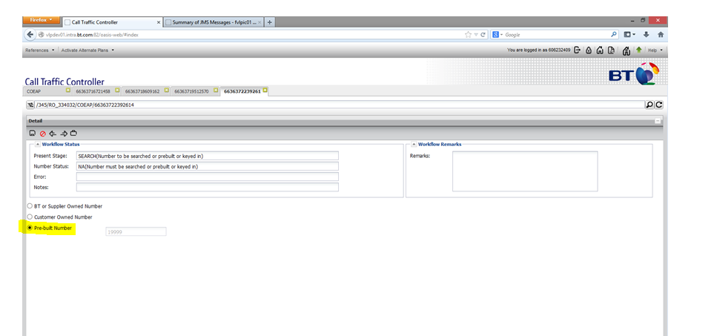

#### VLP Workflow process for Customer owned number- Internal Customer

1. For Customer owned number, user to select the Radio button in VLP.
2. Dialled access number selection screen should be bypassed for user by VLP.
3. VLP to provide the placeholder for user to manually provide the Dialled assess number in Text box.
4. VLP to check the number in Firebird sheet to check if this is “Natively Delivered”.
5. VLP to check if the number is present on MNUM, if not Create the number in allocate state against the Corp ID.
6. In case the number is natively delivered User would not be taken to the Manual DDI screen.
7. If the number is not delivered natively the user will be taken to the Manual DDI selection screen
8. User to select the DDI from Manual DDI selection screen on the basis of country, switch and trunk.
9. Follow the steps from 7 to 11 for DDI/Network code selection.
10. Refer Work flow – Sequence diagram for this scenario
11. The below Screenshot highlights the option of Customer Owned Number displayed on VLP – Highlighted in yellow

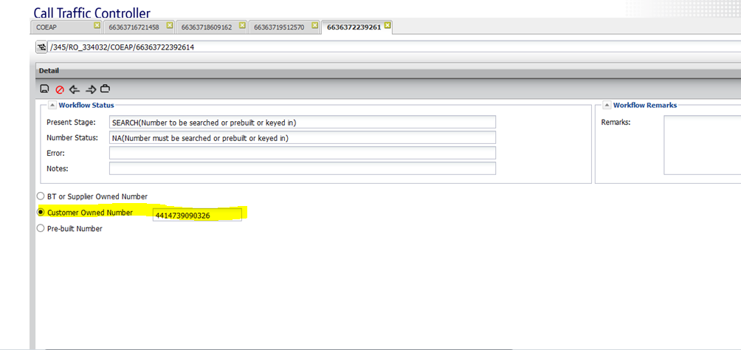

#### VLP Workflow Process for Dialled access number and DDI both are purchased on demand- Internal Customer

1. There are cases when dialled access number and DDI both are purchased on demand. e.g. in New Zealand
2. Once DDIs are purchased from suppliers, this will be the case of prebuilt number. ( In cases where DDI arrives before Access Number)
3. Same process to be followed like prebuilt number process.

#### VLP Workflow Process for UIFN Number Type- Internal Customer

* UIFN is always away from External Customer.
* Order process of UIFN number type is different. Please find below the changes required for UIFN.
* VLP to check internally if this is first time provisioning of that number.
* If number is getting provisioned 1st time then VLP to send the request to MNUM similar like other number type.
* If number is getting provisioned second time then VLP should not send any request to MNUM. VLP is to assume that number is already active in MNUM.
* There are different DDIs to be allocated for different countries for same UIFN number.
* DDI selection screen should be provided each time when a UIFN number is getting provisioned.
* User to select the DDI each time when a UIFN number is getting provisioned.
* User can select the DDI for any country. It is not tied up to the country where service (UIFN Number) is being launched. Toni has taken an example of UIFN number where DDI is always from UK but service is for different countries.
* Same process to be followed for UIFN cease request. VLP to check whether this is last UIFN cease request.
* If last UIFN cease request, then only send the cease request to MNUM otherwise no need to send any request to MNUM for UIFN. But DDI cease request has to be sent to MNUM every time whenever getting a cease request.
* Refer Work flow – Sequence diagram for this scenario
* **NOTE – UIFN Can-not have pre-mapping of the DDIs – Since UIFN can only appear once**

#### VLP Workflow process for external customers:

1. External customer will login to VLP and provide the country; access type and number look up.
2. VLP internally queries the MNUM and gets the next 3 numbers.
3. Customer can select one number out of 3 access numbers and proceed with order process.
4. VLP will first check the number in Firebird sheet, if number present in Firebird sheet then this is the case of natively delivered numbers.
5. If number not present in Firebird sheet, then VLP to check the access number in DDI mapping sheet and derive the respective DDI corresponding to access number.
6. If number is not in DDI mapping sheet also then VLP to display the error message to External Customer “Workflow cannot be progressed further.”
7. Simultaneously VLP to trigger the email to Ops team for completing the order.
8. If number is not available in both the places (Firebird and DDI mapping), VLP application will automatically contact with the respective person. Design team to confirm on this. An auto generated email will be triggered by VLP.
9. Refer Work flow – Sequence diagram scenario

UIFN flow of Inbound gateway:

1. VLP to keep the UIFN process after capturing UIFN actual access number instead of 19999.

#### World Zone 1 Numbers:

* It was highlighted that technically any US DTF number can become a WZ1 number, hence they are not a distinct number type per se. This implies that they cannot be stored as anything other than US DTF numbers in MNUM, nor should they be stored in a separate “World Zone 1” country.
* To allow these numbers to be put into service as an Access number from other NANP countries, VLP will have a flag that when ticked will allow an existing Access Number to be re-used with a new DDI termination in a different country.
* No Impact on MNUM because of this

## VLP Enhancement for self-service:

#### Enhanced historical dial plans

* VLP used to keep the historical dial plan for 3 months after ceasing a number.
* As per T2R (Nickytesh) team, they are expecting the historical data in VLP which is not available for a number more than 3 months after cease.
* VLP to hold the historical dial plan data.

#### Bulk upload using AN workflow

* Provisioning team requested to provision multiple numbers at a time.
* Currently VLP workflow is restricted to provision one number at a time.
* VLP to provide the functionality to load multiple numbers for provisioning.
* Internally VLP creates a single workflow for each number and follow the same order workflow process like single numbers.

#### A new number state called "PreMapped DDI"

* To restrict the user not to select the DDIs which are already mapped to as part of access number to DDI mapping.
* Currently the DDIs which are used in access number to DDI mapping can be used by any user.
* VLP to change the Ringfence ID from “ReservedForDDI” to “PreMappedDDI” as part of AN-DDI mapping sheet upload.

#### Splitting Order Manager dates to be captured in 2 stages

* Dates which were captured earlier in initial stage itself by Order manager will now split in 2 stage.
* Initial stage will have 3 dates
  + 1. SIO acceptance Date
    2. Customer Commit Date
    3. Customer Signed Date
* Rest of the dates will be moved to last stage of order completion stage.

#### Mapping real CC to VLP’s dummy CC before sending them to MNUM

* VLP is using the dummy country code for countries having the same Country code e.g Canada-838.
* MNUM is only expecting the real country code in each interaction with VLP.
* VLP to keep a mapping of dummy country code to real country code, so that before sending this to MNUM, VLP has to convert the dummy country code to real country code.

#### Workflow Handover Notification Emails and tracking dates during handover

* VLP workflow will be done in 2 stage.
* Initially Order management team (Ian’s Team) will start the order workflow.
* Order management team will get the access number and provide the necessary details.
* Order management team will submit the order.
* Order will now move to Provisioning team (Reed’s Team).
* VLP to send the notification email with time stamp as soon as Order management team submit the order.
* Reed’s team will take the order and provide the information like DDI, Dial plan etc.
* Finally, Reed’s team will submit the order.
* VLP to trigger the notification email with time stamp to Ian’s team.
* Order will again move to Ian’s team bucket.
* Team will provide the necessary dates and Access number if it is a case of prebuilt number and Complete the workflow.
* VLP to capture the date and timestamp for each handover for reporting purpose.

#### Data Migration for Trial launch and Final launch

* VLP to write few script to collect and cleanse the VLP data.
* Design team to provide the business rule after analysing the data.

#### MNUM DB sharing issue

* MNUM is using the same database schema and code for GSIP Onevoice and other GS product with ICg.
* There are cases where one number can have both the services Onevoice and ICg.
* There are cases where number range belongs to one product and other product want to use the number.
* To mitigate this issue, we had multiple discussions with different solutions. Finally we have come up to create a separate schema and code base for ICg.
* Please refer the below link for MNUM detailed design for DB sharing issue.

<https://office2.bt.com/sites/ICgDesign/Design%20Documents/Self%20Service/LLD/MNUM/MNUM%20Implementation%20of%20New%20ICG%20Schema_Issued_v_1.0.doc?Web=1>

## 

## VLP – BFG Interface Impacts

1. As part of this design we need to write the Access Number Inventory into BFG through VLP. For writing the data into BFG VLP should know the validated BFG Customer Id information which is bare minimum required and rest of the Site, contract, Location, Address, Site Service and Contract Service would be created as mentioned below.
2. VLP would have the BFG Customer ID before creating Site, contract, Location, Address, Site Service and Contract Service.
3. For new customer orders for CIS-Access Numbers(Which would now be ordered through VLP), VLP will create new Contracts, Site, Loc, Address etc. on BFG and not use ID’s created by any other Applications.
4. For orders which have been initiated from VLP, VLP will maintain a local copy of all the details generated by BFG. So these will be used for Modify & Cease scenario.
5. For few of the attributes during creation of Site, Contract, Loc, Address etc., VLP will send some dummy value to BFG for as these are mandatory and not available in the VLP system. Product line has agreed to it as some of these values are only used by the T2R team for ticket enrichment & the process design will include these changes for agreement with SDA team. In case of inbound contact global, BFG data is only used by Expedio IM for ticket enrichment and no other system uses this data.
6. As part of this requirement BFG to expose jms services to VLP to create non-technical inventories of Contract, Contract Service, Site, Address, Location and Site Service. These inventories will be required in BFG to create technical inventory of Network Service with name ‘Generic PTP Network’ as part of Inbound Contact Global.
7. MCI service would be used for creation of Contract, Contract Service, Site, Address, Location and Site Service. MSCI service would be used for creation of Network Service with name ‘Generic PTP Network’. In above cases, while creation of inventories, VLP will send its id for the corresponding inventory type in MCI and MSCI request. BFG will store the VLP id/s in **bfg_foreign_business_keys** and **bfg_element_keys** table as external reference depending on type of inventory.
8. Single Contract, Contract Service, Site, Address, Location, Site Service and Network Service would be sent in each MCI and MSCI request and same would be created in BFG. Post successful creation of inventory in BFG, MCI and MSCI notification will be sent having BFG inventory id. Site and Address would be created in same MCI request and BFG will send notification having BFG site id. Sample handcrafted MCI and MSCI request xml’s has been enclosed below. Also enclosed BFG – VLP mapping sheet.
9. Value for attribute ‘contractClientGroup’ needs to be populated by VLP from the CNOC sheet attached in below section. The value will be picked based upon revenue owner.
10. For Business Channel VLP to populate the value as “Unknown” as BFG doesn’t hold the value of Business Channel
11. Standard Care SLA to be sent for the SLA field

## ESB – Enterprise Service BUS

ESB acts as a mediator between VLP AND MNUM (LIANS). ESB to allow VLP to consume MNUM interface and will receive requests from VLP and will pass the same to MNUM. ESB will also send back responses received from MNUM to VLP.

Currently ESB is supporting following calls/operations between MNUM and VLP

1. activateNumberRequest
2. allocateNumberRequest
3. cancelNumberRequest
4. cancelRingFenceNumberRangeRequest
5. ceaseNumberRequest
6. ceaseRingFenceNumberRangeRequest
7. confirmRingFenceNumberRangeRequest
8. createRingFenceNumberRangeRequest
9. exportNumberRequest
10. getAvailableNumberRequest
11. getNumberDetailsRequest
12. importNumberRequest
13. modifyRingFenceNumberRangeRequest

* ESB to support WSDL version 7.0 for this product

ESB will have HTTP Interface with VLP

1. There will be synchronous HTTP request response between VLP and ESB.
2. In case of any errors, ESB will be sending standard HTTP error codes.
3. Time out at ESB is 120 Seconds.

List of operations mentioned are generic and will be used with various combinations (example Import Cease, Cease is used as Quarantine etc.) as well which were discussed in detail on CFTs and updates XMLs are shared with all components. ESB is advised to follow the discussions and XMLs.

MNUM:

For supporting the individual number cease/ un-ring-fence Action tag is getting introduced at MNUM end for following operations –

1. confirmRingFenceNumberRangeRequest
2. cancleRingFenceNumberRangeRequest
3. modifyRingFenceNumberRangeRequest

Below are the Mock XMLS



Name space Attributes provided below – Root Tag would change as per the operation

|  |  |
| --- | --- |
| **Attribute** | **Value** |
| Root Tag | cancelRingFenceNumberRangeRequest |
| Namespace URI of Root Tag | <https://collaborate.bt.com/svn/sdkrepo/adli/22/tags/4.0/ManageNumber/> |
| From | <http://capabilities.nat.bt.com/VLP> |
| To | <http://capabilities.nat.bt.com/ManageNumber> |

## Billing and Mediation

1. If the rates are not available for CDRs the records will go to suspense directory.
2. Billing ops to analyse the suspense records and contact to respective account manager for the rates
3. Billing ops to configure the rates provided by account manager in cyclone
4. Billing ops will refer to VLP report ( VLPs MDP report will be displaying the Creation Date)only in case of the external customer for identifying if there is addition of new access number. For Internal Customer its BAU

## BFG

1. BFG to expose API’s to VLP to create Contract, Address, Site and Service related data into BFG through VLP-IC for Access Numbers.
2. The same interface will be used for provide, Modify and Cease scenarios for updates to BFG.
3. Detail xml’s and attribute data mapping is detailed in section below.
4. Only the assets created through VLP in BFG can be modified and ceased from VLP. In the following release when data uplift happens in BFG and VLP, Assets created through IPMS for CIS-Access Numbers can be modified and ceased.(Agreed with Platform Architect Sandeep Kumar & Kathleen)
5. BFG would provide new inbound queue to consume MCI xml from VLP. Will provide new outbound queue for MCI notification xml. VLP will create jmsbridge/configuration to push and pull MCI xml from/to BFG.
6. MSCI xml communication will use existing inbound and outbound queue used for One Cloud Cisco (OCC).
7. BFG id’s created as part of MCI would be sent in MSCI xml while creating network service (name – ‘Generic PTP Network’) in BFG.
8. BFG would insert/update inventory as par data send in MCI and MSCI xml without any translation or transformation.
9. For new customer orders (which would now be ordered through VLP), VLP will not use ID’s created by any other Applications.
10. For orders which have been initiated from VLP, VLP will maintain a local copy of all the details generated by BFG. So these will be used for Modify & Cease scenario.BFG customer id, Site id, Contract id, Location id, Address id, Site service id.
11. Data created by VLP will be used by Expedio IM for ticket enrichment, this will be BAU.
12. SRN’s the way it was created from IPMS will change and in its place Application Id which identifies a CORP ID Access Number would be used from this release.
13. The Various XMLS for this interface and the mapping sheet are available in the reference section

## Provide Order Business Scenarios:

#### Natively Delivered DTF/ITF/Geo/etc

* Provides where DTF/~~ITF~~/Geo/etc. numbers are natively delivered to us. Dialled access number itself is the network address.
  + BT User/External customer login to VLP for self-service.
  + User to select the access type, Country, number lookup in VLP.
  + VLP internally queries the MNUM as per search criteria and fetch the numbers in VLP.
  + User to select one number and proceed in the VLP order workflow.
  + VLP internally queries that number in Firebird sheet and try to check whether number is present in Firebird sheet. (For natively delivered scenario, Number should present in Firebird sheet).
  + VLP fetches the Switch and Trunk information from Firebird sheet.
  + Routing plan to be configured in VLP and proceed with the number provisioning process.
* Note ( ITF would not be natively delivered)

Call Flow for Natively Delivered DTF/ITF/Geo/etc.

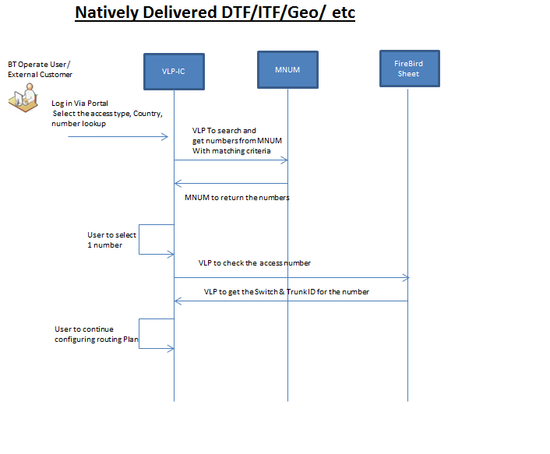

#### Provides with Up-Front Mapping of Dialled Access Number and DDI

* + Provides where DTF/ITF/~~Geo~~/etc. are mapped to DDIs by VLP. This is the case when Dialled access number and DDIs are mapped upfront and mapping is kept in VLP.
  + BT User/External customer login to VLP for self-service.
  + User to select the access type, Country, number lookup in VLP.
  + VLP internally queries the MNUM as per search criteria and fetch the numbers in VLP.
  + User to select one number and proceed in the VLP order workflow.
  + If number is not present in Firebird sheet then, VLP checks the number in DDI mapping sheet which VLP kept in their database.
  + As this is the scenario to present the number in DDI mapping sheet, VLP finds the respective DDI corresponding to Dialled access number.
  + After getting the DDI, VLP checks the DDI in Firebird sheet to fetch the switch and trunk information.
  + Routing plan to be configured in VLP and proceed with the provisioning process.

(Note – This case of Having the Pre-mapping of Access Number to DDI would not be applicable to Geo and PSTN – as these will always be natively delivered)

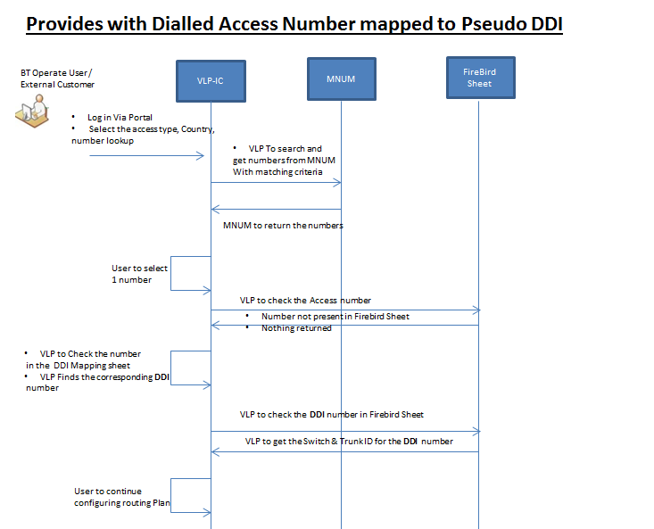

#### Provides with manual Mapping of Access Number to DDI

* + Provides where DTF/ITF/Geo/etc. are mapped to DDIs via a manual process led by ops. Manually Ops team to select the number from MNUM as per search criteria.
  + BT user login to VLP for Self-service.
  + User to select the access type, Country, number lookup in VLP.
  + VLP internally queries the MNUM as per search criteria and fetch the numbers in VLP.
  + User to select one number and proceed in the VLP order workflow.
  + If number is not present in Firebird sheet and DDI mapping sheet then, VLP redirect the user to manual DDI selection screen.
  + User to provide the information like Country, Switch Details, Number type as ‘Geo Number’.
  + VLP internally queries the DDI from MNUM.
* User to select one DDI and proceed with order workflow.
* After getting the DDI, VLP checks the DDI in Firebird sheet to fetch the switch and trunk information.
* Routing plan to be configured in VLP and proceed with the provisioning process.

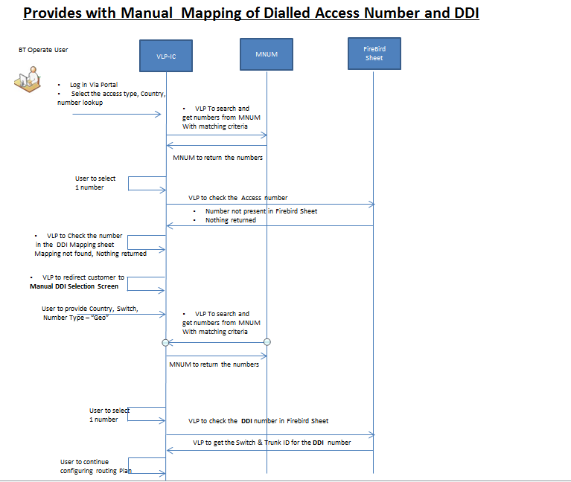

#### Provides where DTF/ITF/Geo/etc. are mapped to pseudo DDIs.

* + Provides where DTF/ITF/Geo/etc. are mapped to pseudo DDIs. These are the network codes configured against the Dialled access number. These network codes are manually selected by Ops user from the MNUM.
  + BT user login to VLP for Self-service.
  + User to select the access type, Country, number lookup in VLP.
  + VLP internally queries the MNUM as per search criteria and fetch the numbers in VLP.
  + User to select one number and proceed in the VLP order workflow.
  + If number is not present in Firebird sheet and DDI mapping sheet then, VLP redirect the user to manual DDI selection screen.
  + User to provide the information like Country, Switch Details, Number type as ‘NWRC’.
  + VLP internally queries the Network Code from MNUM.
  + User to select one Network Code and proceed with order workflow.
  + After getting the Network Code, VLP checks the Network Code in Firebird sheet to fetch the Hex Code associated with the network code. Apart from that VLP fetch the switch and trunk information.
  + Routing plan to be configured in VLP and proceed with the provisioning process.

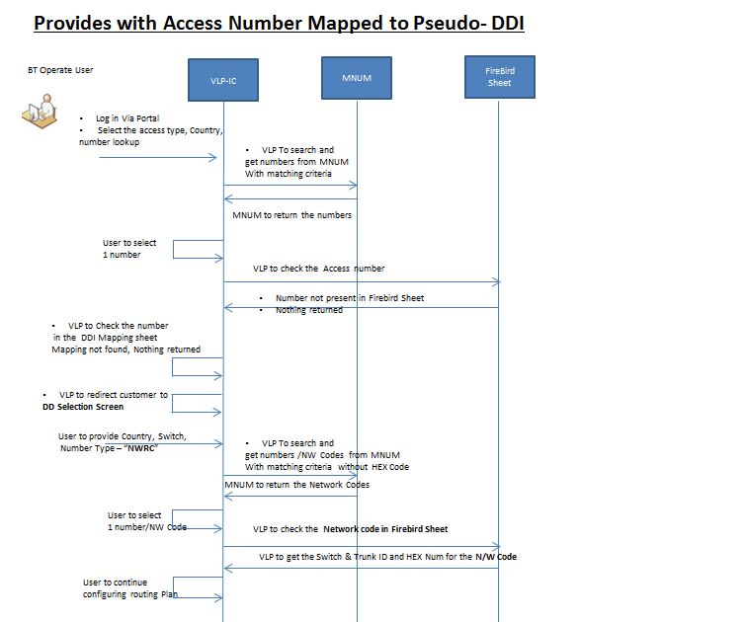

#### Provides using pre-built numbers.

* These are the cases when Dialled Access number is not available. By the time BT purchase the number from supplier, DDI should be configured.
  + BT user login to VLP for Self-service.
  + User to select the prebuilt radio button on VLP screen.
  + VLP to bypass the dialled access number selection.
  + VLP automatically selects the Dialled access number as “1999” which is a dummy number.
  + VLP directly move to manual DDI selection screen.
  + User to provide the information like Country, Switch Details, Number type to fetch the DDI/Network code. BT user is having intelligence to define whether it is a DDI or a Network code.
  + VLP internally queries the DDI/Network code from MNUM.
  + User to select one DDI/Network code and proceed with order workflow.
  + After getting the DDI/Network Code, VLP checks the DDI in Firebird sheet to fetch the switch and trunk information.
  + Routing plan to be configured in VLP and proceed with the provisioning process.
  + After that BT user provides the dialled access number in VLP with supplier details.
  + VLP fires the request to create this number in MNUM in allocate state.

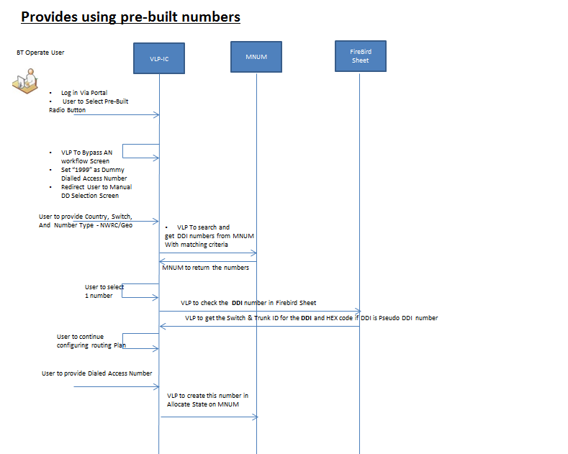

### 

#### Provides using customer owned numbers.

* When Customer owns their own Dialled access number and purchase only service from BT.
  + BT user login to VLP for Self-service.
  + User to select the Customer Owned Number radio button in VLP screen.
  + VLP bypass the dialled access number selection.
  + VLP directly move to manual DDI selection screen.
  + VLP to provide the placeholder for user to manually provide the Dialled assess number in Text box.
  + VLP to check the number in Firebird sheet to check if this is “Natively Delivered”.
  + VLP to check if the number is present on MNUM, if not Create the number in allocate state against the Corp ID.
  + In case the number is natively delivered User would not be taken to the Manual DDI screen.
  + If the number is not delivered natively the user will be taken to the Manual DDI selection screen
  + User to select the DDI from Manual DDI selection screen on the basis of country, switch and trunk.
  + Follow the steps from 7 to 11 for DDI/Network code selection.

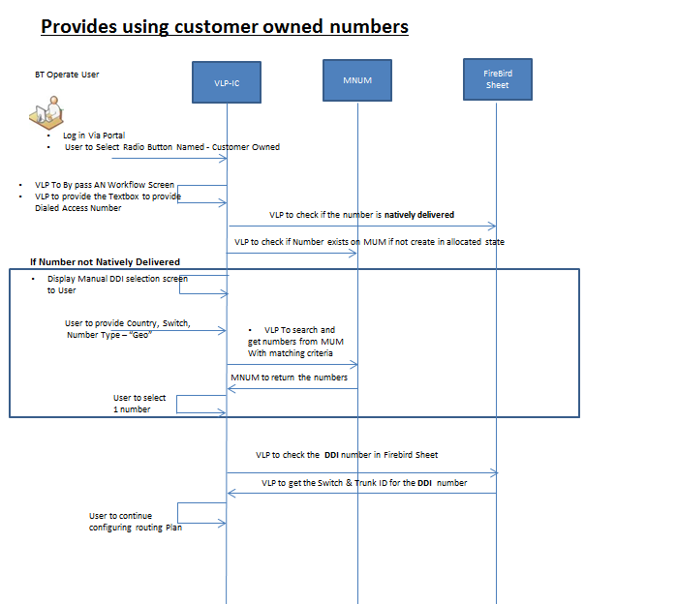

#### Provides using UIFNs (Universal international toll free numbers).

* These numbers are not country specific. Same number can be launched in different countries. For each country there is a separate DDI to be configured. DDIs are not country specific too.
* BT user login to VLP for self-service.
* User to select the access type as UIFN.
* User to provide the UIFN number in the text box in VLP screen.
* VLP internally checks that number in VLP database whether this is first time provisioning of that number.
* If number is coming first time, then VLP to ask user to select the country and other details.
* If the number being provisioned first time then VLP needs to create this Number in MNUM in allocate state against the particular corp id and country should be selected as Global.
* VLP will internally pass country name as Global for UIFN Numbers.
* VLP also needs to keep the data for the UIFNs- as a single UIFN can be used in multiple countries. On MNUM the number can be kept just once.
* VLP internally queries the MNUM as per search criteria and fetch the same number in VLP.
* VLP to follow the same process like other access/number type.
* VLP redirects the user manual DDI selection screen.
* User to provide the information like Country, Switch Details, Number type as ‘Geo Number’.
* VLP internally queries the DDI from MNUM.
* User to select one DDI and proceed with order workflow.
* After getting the DDI, VLP checks the DDI in Firebird sheet to fetch the switch and trunk information.
* Routing plan to be configured in VLP and proceed with the provisioning process.
* If UIFN number is not getting provisioned 1st time, then VLP assumes that number is already present in reserved/working state in MNUM.
* VLP will not pass request to MNUM in such case.
* VLP directly routes the user to manual DDI selection screen.
* There user has to follow the same steps like earlier.
* **Ceasing of the UIFN –**
  + If a request is made to cease the UIFN for a specific country – VLP needs to send the cease requests for the DDI(s) used for that UIFN in the particular country and send cease requests for those DDI(s)
  + UIFN can only be ceased – if its ceased for countries and corresponding DDI(s)

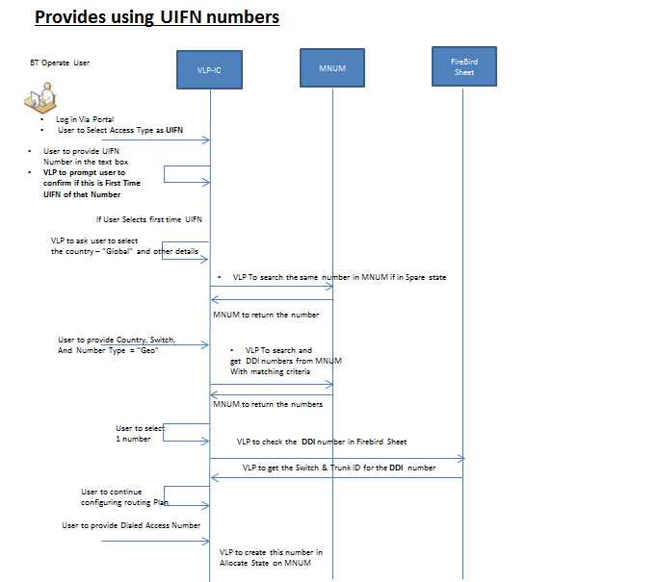

#### Country/Access Type and Provide Scenarios supported - Mapping Sheet

* The below sheet (work in progress) provides the countries, the access types supported in that country and the Provide Scenarios



|  |  |  |  |  |  |
| --- | --- | --- | --- | --- | --- |
| Sr NO | Scenario | VLP Access Type | Countries |  |  |
| 1 | Natively Delivered DTF/ITF/Geo/etc |  |  |  |  |
| 2 | Provides with Up-Front Mapping of Dialled Access Number and DDI |  |  |  |  |
| 3 | Provides with manual Mapping of Access Number to DDI |  |  |  |  |
| 4 | Provides where DTF/ITF/Geo/etc. are mapped to pseudo DDIs. |  |  |  |  |
| 5 | Provides using pre-built numbers. |  |  |  |  |
| 6 | Provides using customer owned numbers. |  |  |  |  |
| 7 | Provides using UIFNs (Universal international toll free numbers). |  |  |  |  |

# Risks

|  |  |  |  |  |  |
| --- | --- | --- | --- | --- | --- |
| No | Area | Issue | Owner | Status | Status Notes |
| 1 | VLP | Whether it is required for VLP to generate SRN? | Kathleen/Dipak | Closed | Agreed that SRN is not required. Instead Application ID would be used and SDA to include this and get it agreed with the team. |
| 2 | IPMS | Performance reports | Jennifer/Dipak | Closed | Call happened with Ian Robson approach is to generate reports through VLP. |
| 3 | BFG/Agora/GSEDW | Do we need to send Access Number and SRN information to BFG | Kathleen/Dipak | Closed | Call with Operations team to confirm. |
| 4 | Product | Do we only need to support provide journey for Access numbers? Or we can also support modify and cease of an Access number service | Kathleen/Suhas | Closed | Provide/Modify & Cease to be supported in this release for data/assets generated from VLP. For legacy data generated from IPMS, modify and cease to be supported in subsequent release as it will need data uplift in BFG and VLP. |
|  |  |  |  |  |  |

**Stakeholders: Business, Technical, Delivery**

**Risks**: A risk is any specific event which might occur and will have a negative impact on your design/solution. It is the probability of an event occurring detrimental to the solution. A risk could be business related risk, design related or delivery related. All types of risks should be considered. All stakeholders should be kept informed of the risks and the risks should be mitigated by assumptions and agreements with the stakeholders (i.e. business, component, architects, and delivery).

# Assumptions

|  |  |  |
| --- | --- | --- |
| **Sr No** | **Description** | **Status** |
| 1 | Network codes are country specific | Closed. Discussed on series of calls with Toni |
| 2 | Network codes/Hex will either be suffix or prefix to the numbers | Closed. Discussed on series of calls with Toni |
| 3 | No Trunk Info needed while searching for the DDI | Closed. Discussed on series of calls with Toni |
| 4 | There is no choice of DDI selection (Confirmed from Toni). Always next available DDI is chosen by use | Closed. Discussed on series of calls with Toni |
| 6 | Suppliers for Network codes can be identified by the number pattern. E.g. 111 to 115 is always with Verizon. Likewise they can identify. Ops team can identify the network code for a particular supplier by seeing the number pattern. | Closed. Discussed on series of calls with Toni |
| 7 | Maximum Quantity for access number search is 600. | Closed. Discussed on series of calls with Toni |

**Assumptions**: An assumption is a design decision made to enable the design to be progressed at the start of the CA/CFT. Design decisions made during the CFT should not be mentioned in the assumption unless it has an associated risk. Instead such design decisions should be agreed with the components and relevant stakeholders (if required) and mentioned as a part of the functional design. All assumptions should monitored be closed/ agreed by the end of the CFT.

# Issues

|  |  |  |
| --- | --- | --- |
| **Sr No** | **Description** | **Status** |
| 1 | Cyclone will be using the App id to configure the billing instead of SRN number. App id will not be unique anymore. | Open, Discussions going with product Line |
| 2 | What needs to be done with the BT owned number after the Cease request. As per the discussion with Shaun, these numbers should be moved to Spare number pool. Current logic at MNUM end to delete all the numbers from MNUM after cease request irrespective of number are BT owned and Supplier owned. | Open, Discussions going with product Line |

**Issues**: Issues are any pressing points that may block the solution (fully or certain aspect of the solution) from being designed (completed). Issues are different from risks, as issues are problems that exist today, unlike risks that may arise at a later date. All issues need attention and resolution immediately. There should be no open issues at the end of the CFT.

# Design Decisions

|  |  |  |  |
| --- | --- | --- | --- |
| **No** | **Area** | **Discussion Point** | **Agreement** |
| 1 | Number Management | As a strategic approach, No new functionality can be developed in IPMS system and hence proposing to use MNUM for number management. | Agreed to use MNUM as it is the strategic way forward. |
| 2 | VLP-IC | Tree view GUI for Access Numbers/Application ID/Dial Plan which was requested by product will not be delivered in this release. VLP has agreed to do it as a platform led initiative later | This can be delivered by VLP as part of Non Release based activity. |
| 3 | Number Management | Port In and Port Out will not be supported in this release. | This release would not support Port In/Out of Numbers on MNUM. |
| 4 | Number Management | All numbers must necessarily be uploaded into MNUM before we start to use VLP for provisioning. | Agreed with Kathleen. A single number too can be uploaded on MNUM(Confirmed by Manthan from MNUM) |
| 5 | Number Management | In case if a number is provided back to supplier that has to be remove from MNUM automatically once a cease request is sent from VLP. | Discussed and closed |
| 6 | BFG updates | BFG data mapping: New logic to be built for Contract, Site, Location, Address and technical inventory as discussed in CFT calls | Agreed with BFG/VLP and Product Team. |
| 7 | VLP | VLP to support inclusion of BFG customer Id as a mandatory attribute during customer on board process. | Agreed with VLP and Product Team. |
| 8 | VLP-BFG | Populate value of Business Channel as “Unknown” | Agreed with Kathleen |
| 9 | MNUM Changes | The agreement from MNUM on delivering the following functionalities   * US/Canada Country code Issue * New Division level Launch at ICG * Cancellation of Individual Ring-fenced numbers * MNUM Permanent Deletion of Deleted Numbers * MNUM Modifying Number Corrections due to mistakes * MNUM Country Number Plan Updates * MNUM Changes to reference data * Creation of BT Owned/Supplier owned Numbers from VLP to * MNUM should support the number search based on just Div 2 value if Div 3 value is not sent * 2 Number types to be created.  1. NWRC 2. National * Additional Reports | Confirmation email from MNUM in attached in reference section |
| 10 | Pseudo DDI | Pseudo DDIs ( network Code) are always associated with a country hence data to be loaded for these DDI against a particular country and switch | Closed. Discussed on series of calls with Toni |
| 11 | Supplier Info for DDI | On VLP we would not be having an option of selecting a Supplier , from the number search string Ops can understand the supplier | Closed. Discussed on series of calls with Toni |

# Process/Configuration/Data Load on MNUM & VLP

### 8.1 MNUM

* Country data load to be provided to MNUM to load against DIv2.
* Corresponding Country ISO code mapping to be provided to MNUM.
* Div3 will hold switch information corresponding to each country.
* Same country to be defined in DIv3 as well as a dummy country.( such entry should be there for each country – specially for access number case – as Access number do not have any switch info. Having DIv3 introduced at MNUM end – it expects the value for Div 3 hence for Access Number such entry should be there on MNUM)
* All numbers are to be loaded in Div3. (Dialled access number, Geo Numbers, Network code).
* Dialled access numbers (DTF, ITF, Shared cost) are country specific. That is why dummy countries are defined in DIv3 to load these numbers.
* All geo numbers and Pseudo numbers are loaded against the actual switch in DIv3.
* Geo numbers are to be loaded against access type as “Geo number” and Pseudo codes are to be loaded against access type as “NWRC”
* Geo numbers which are going to be used as DDI will be ringfenced against Dummy Corp id “ReservedForDDI”. This action is to be performed by Ops team whenever loading the number data in MNUM. Once these numbers are ringfenced then, these numbers won’t be available for allocation to any customers as access numbers ( unless the reservation is removed)
* Cancel ringfence for individual number functionality is to bring the number back to spare pool from reserved pool. This is the requirement from Ops team to use the DDI and Geo number interchangeably. So if Ops user wants the number back to spare pool then they can cancel the ringfence of these numbers. ( Via MNUM)
* All the suppliers will be loaded as initial data load activity.
* All the suppliers are to be set as default so that user can create the numbers in MNUM database corresponding to these suppliers.
* There are 2 ways to create the Number data in MNUM.
  + Number data load through MNUM ASG team.
  + MNUM GUI (User can load the numbers through MNUM GUI also)
* Cancel number request is to cancel the ringfenced/Allocated number against a customer. There are cases where user starts the VLP workflow and ringfence/Allocate the number but won’t activate the number. In such cases after a certain time cancel number request will be raised automatically by VLP and number will moved to spare state in MNUM.
* Modify ringfence functionality will be used to reserve the DDI for a customer. Modify ringfence is to replace the dummy ring-fence id “ReservedForDDI” with the actual customer corp id.
* BT returns the number back to suppliers after use. Once there is cease number request the number will get deleted from MNUM completely.
* User can generate Dialled access number reports on the basis of different divisions (Country, Switch) and Number status, Number type.
* User can generate the reports for available DDIs by using the ringfenced number reports on the basis of different division.
* MNUM will provide the One of script to make the changes in reference data in MNUM i.e. Country addition, Number type addition, Number data change etc.
* Process is to raise a request to MNUM ASG team in certain input format (Format will be decided in LLD). Detailed process will be provided in service design documents
* For prebuilt numbers: Dialled access numbers are to be created on the fly from VLP to MNUM in allocate state. MNUM to provide the API to create the BT/Supplier owned number from VLP.
* MNUM will provide the one-time script for country number plan change.
* Whenever country number plan is being changed then, need to raise request to MNUM ASG to change the numbers in certain input format (Format will be provided in LLD).
* UIFN numbers are not country specific. Dummy country called as **Global** with Country code as “**999**” to be defined in MNUM DIv2 and same to be defined in Div3 as well.

### 8.2 VLP

* There will be 3 user groups at VLP end to access the VLP. All are having different set of permissions.
  + External Customer
  + BT operate User Ops team
  + BT operate User provisioning team
* User to load the DDI mapping sheet in VLP before starting the order process. – this could be done on Screen as well for single Mapping or upload the sheet in case of bulk upload. ( Mainly the sheet to have two columns – Access and DDI)
* Supplier Info to be loaded on VLP
* Switch and Trunk mapping to be maintained/initial data load to be done
* ISO Code data to be loaded on VLP
* When the new supplier is created on MNUM, the same has to be created on VLP as well via VLP Screens
* **To Support T2R process – VLP to display ceased order details , for this VLP to provide new screen which will be available in full launch (January -18).**
  + - The data that VLP will store will be post go-live in January 2017. Any cease details required prior to it can be found in IPMS system. The data deleted post Jan will be available will be available for 3 years
  + - Second line team can search with App ID on the current search screen and if the access number is active it will be displayed.
  + - If the number is not displayed then a search can be done in the new screen (to be developed).
  + - RCE team can also check details in order screen which has data of about 3 months and is been used in current process.
* Second line team would require a presentation document which will help them to create their low level instructions and can then be moved ahead for signoff.
* No training sessions will be scheduled as the team is already using VLP system to handle existing requests

# E2E/CIT Test Scenarios

* Loading of the numbers in MNUM
* Validation of customer in VLP IC while entering the BFG customer Id.
* Raise a provide order in VLP IC with all the features enabled for customer and network address is available and to check with multiple suppliers
* Raise a provide order in VLP IC with all the features enabled and customer usage is more than 50,000 minutes/month
* Raise a Cease order in VLP IC with all the features enabled
* Test all the Provide Scenarios for Internal Customer (Happy Path)
* Test all the Provide Scenarios for External Customer (Happy Path)
* Test all the Provide Scenarios for Internal Customer (Negative)
* Test all the Provide Scenarios for External Customer (Negative)
* Ceasing the Number

( The detailed Scenarios will be discussed during low level discussions)

# Non-Functional Considerations

* Estimated Access numbers delete orders.  These are the number of orders for the past 3 months.

                June 2016 – 46

                July 2016-  7

                August 2016 - 20

* Reserve, allocate, activate should all be approximately the same.   We issued the following number of orders to install access numbers:

                June 2016 – 329

                July 2016 -   340

                Aug 2016  - 280

* Future forecast Per Month:

Cease: 30

* Reserve+Allocate+Activate: 350

.

# Future Enhancements –

* BT Owned number needs to go to spare state after ceased ( after defined period)
* Supplier creation to be controlled from VLP – once the supplier created on VLP – info could be sent to MNUM
* Multiple numbers can be created on the fly in VLP. Internally VLP to split each number in a single workflow and send it to MNUM.
* For external customers – during self-service just display the numbers which are either found in Firebird sheet.
* Few functions to be moved from VLP to other systems – e.g. generating a quote, creating contract, site.
* Searching the DDI based on the suppliers – e,g searching number for Verizon in USA. ( On the Manual DDI mapping screen)
* MNUM has to provide an API to VLP to get the List of Div 3 values if Div 2 value is provided. Need to discuss in detail design ( could be covered in point 2)

# Requirement Conformance

The Compliance is provided against the requirement in the sheet attached below. Requirements are picked from the Original SOR



# VLP MNUM – Phased Delivery and Provide Scenarios Mapping

* The attached below document lists all the new changes requested at VLP and MNUM end, their delivery timelines and the Provide Scenarios which will be covered during these timelines



### Glossary

|  |  |  |
| --- | --- | --- |
| Glossary Term | Meaning | Additional Notes |
|  |  |  |
|  |  |  |
|  |  |  |
|  |  |  |

### References

|  |  |
| --- | --- |
| Reference | Meaning |
| Two new operations support at ESB End | As part of R47 delivery – two operations were not supported at ESB End createRingFenceNumberRangeRequest and cancelRingFenceNumberRangeRequest  . The confirmation and MOM email attached |
| VLP-BFG Interface and Mappings |  |
| Confirmation from MNUM on the changes requested |  |
| Network Document |  |
|  |  |